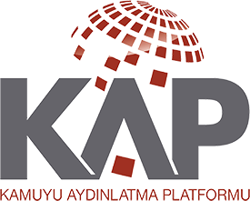
PUBLIC DISCLOSURE PLATFORM

AYEN ENERJİ A.Ş.
Disclosure on the News and the Rumors

Summary Info
Disclosure regarding the news published about our Company

Disclosure on the News or the Rumors

Respective Companies []
Related Funds []

Disclosure on the News or the Rumors
Is the Disclosure an Update? | No
Is the Disclosure a Correction? | No
Date of the Previous Disclosure on the Subject | -
Is the Disclosure a Deferred Disclosure? | Yes
Notification Content
Disclosures

The Disclosure of our Company, in accordance with the CMB's Special Circumstances Communiqué (II-15.1), upon the news published by a news agency, is presented below:

Our Company has signed a financial consultancy contract with Pragma Finansal Danışmanlık Hizmetleri Ticaret A.Ş. with the purpose of evaluating the strategic and financial cooperation opportunities, concerning the sale of some or all of the shares of our Company's subsidiaries established in Albania,

Considering that the value of the capital market instrument of the company and the investment decisions of the investors may be affected due to the uncertainty of the transaction, the Board of Directors has decided to postpone the public disclosure on 02.09.2019, in accordance with the provisions of the Capital Markets Board's Communiqué numbered II-15.1.

In this context, there has been no final development at this stage that would require public announcement. The relevant developments will be announced within the scope of the legislation.

We hereby declare that the foregoing disclosures are in accordance with the principles stipulated in the Capital Markets Board Communiqué in force on Special Circumstances, that they fully reflect the information we have received on the issue (s), that the information is in compliance with our books, records and documents, that we have made all necessary efforts to obtain complete and accurate information on the subject and that we are responsible for such disclosures.

